# District Information

## About the Los Angeles Community College District

Over the past seventy-seven years the Los Angeles Community College District (LACCD) served as educator to more than three million students. LACCD educates almost three times as many Latino students and nearly four times as many African-American students as all of the University of California campuses combined. Eighty percent of LACCD students are from underserved populations. More than half of all LACCD students are older than 25 years of age, and more than a quarter are 35 or older.

The Los Angeles Community College District is the largest community college district in the United States and is one of the largest in the world. The LACCD consists of nine colleges and covers an area of more than 882 square miles.

Figure 1.1 LACCD Colleges

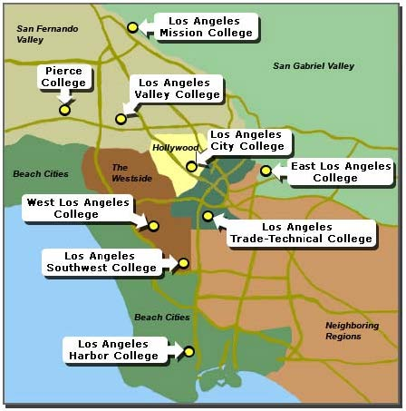

Los Angeles City College

East Los Angeles College

***Los Angeles Harbor College***

Los Angeles Mission College

Los Angeles Pierce College

Los Angeles Southwest College

Los Angeles Trade-Technical College

Los Angeles Valley College

West Los Angeles College

The Los Angeles Community College District offers educational opportunities to students in 40 cities and communities. In 2021-22, LACCD enrolled over 200,00 students.

Table 1. 1 LACCD 2021-22 Enrollments by College

|  |  |
| --- | --- |
| **Annual Enrollment by College, 2021-2022** | **Enrollment** |
| LA City | 26,121 |
| East LA | 52,521 |
| LA Harbor | 11,826 |
| LA Mission | 16,665 |
| LA Pierce | 25,128 |
| LA Southwest | 10,254 |
| LA Trade | 18,255 |
| LA Valley | 24,564 |
| West LA | 19,432 |
| **Total** | **204,766** |
| Source: California Community Colleges Chancellor's Office Data Mart | |

One out of three LACCD students is under 20 years old. Over half (56%) are female. Nearly sixty percent (59%) of the student body is Hispanic.

Table 1.2 LACCD 2021-22 Student Age Distribution

|  |  |
| --- | --- |
| **Age, 2021-2022** |  |
| 19 or Less | 30.1% |
| 20 to 24 | 23.0% |
| 25 to 29 | 13.8% |
| 30 to 34 | 9.5% |
| 35 to 39 | 6.5% |
| 40 to 49 | 8.5% |
| 50 + | 8.6% |
| Unknown | 0.0% |
| **Total** | **100.0%** |
| Source: California Community Colleges Chancellor's Office Data Mart | |

Table 1.3 LACCD 2021-22 Student Gender Distribution

|  |  |
| --- | --- |
| **Gender, 2021-2022** |  |
| Female | 56.4% |
| Male | 42.2% |
| Non-Binary | 0.4% |
| Unknown | 0.9% |
| **Total** | **100.0%** |
| Source: California Community Colleges Chancellor's Office Data Mart | |

Table 1.4 LACCD 2021-22 Student Ethnicity Distribution

|  |  |
| --- | --- |
| **Ethnicity, 2021-2022** |  |
| African-American | 8.6 % |
| American Indian/Alaskan Native | 0.2 % |
| Asian | 6.4 % |
| Filipino | 2.4 % |
| Hispanic | 58.5 % |
| Multi-Ethnicity | 2.4 % |
| Pacific Islander | 0.2 % |
| Unknown | 5.3 % |
| White Non-Hispanic | 16.2 % |
| **Total** | **100.0%** |
| Source: California Community Colleges Chancellor's Office Data Mart | |

# Campus Information

## About Los Angeles Harbor College

### Mission

Los Angeles Harbor College (Harbor College) serves our diverse community by providing access to associate and transfer degrees, certificates, economic and workforce development, and adult and noncredit instruction. We promote equity, diversity, and student success through academic programs and support services that ensure our students become productive members of a global society.

### Vision

Harbor College provides a stimulating learning environment that prepares members within the community to meet goals and opportunities successfully.

### Values

Student Success, Excellence, Integrity, A Supportive Environment, Personal and Institutional Accountability, and Civic Responsibility.

### History

Los Angeles Harbor College officially opened in September 1949. By 1963, the campus grew to include five buildings, including the Seahawk Center—the student activity hub. The College was first known as “Harbor Tech” and then as “Harbor Junior College” before adopting its present name in 1965. The initial enrollment totaled 650 students, mostly male and mostly from nearby San Pedro High School. By 1965, the College had grown to approximately 5,000 students.

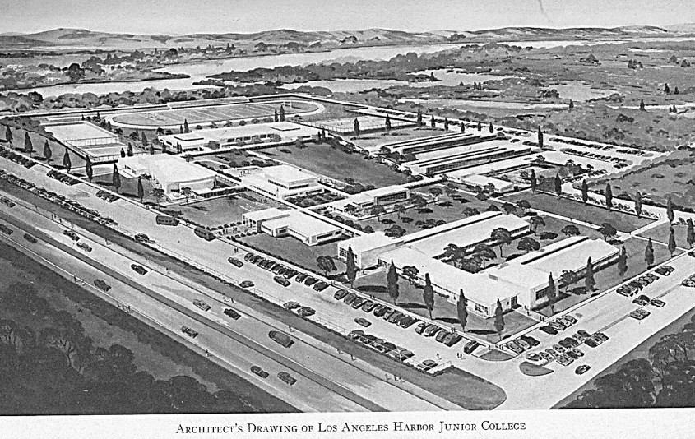

Figure 1.3 Architectural rendering of the new Los Angeles Harbor Junior College from 1949

Over the next 30 years, the campus grew to house more than 10 instructional, student services, and administration buildings. In 2000, the Los Angeles Community College District adopted the largest facilities construction bond issued in the history of the district. With this support, the College renovated the Fine Arts, Theatre, Nursing, and Music buildings and constructed the Northeast Academic Hall, Student Services and Administration building, central plant buildings, the PE/Wellness Center, the Child Development Center, the Science Complex, the Technology building, and the Library and Learning Resources building.

The new Student Union, opened in 2019, is the most recent building added to the campus footprint. The campus is also the home of the Dr. Richard A. Vladovic Harbor Teacher Prep Academy Middle College High School (aka HTPA), which opened new facilities in 2018 after operating for 16 years in bungalows. A new Southeast Hall, set to open in 2026, will house the nursing program, health center, the Equity Village, and several student support service offices.

Figure 1.4 Los Angeles Harbor College, 2023

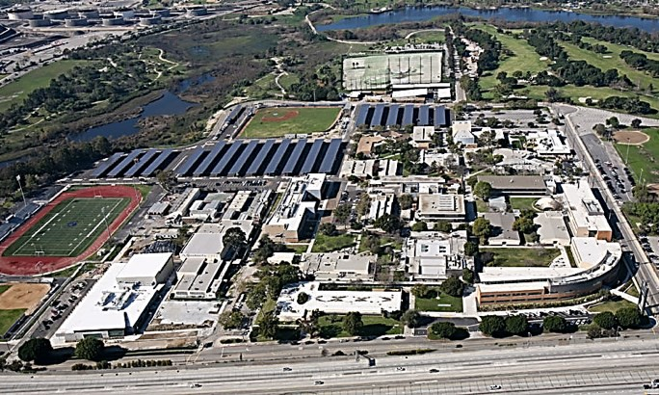

Today, Harbor College enrolls approximately 12,000 students per year serving ten area high schools at a single campus location, approximately 20 miles south of downtown Los Angeles and a few miles from the Port of Los Angeles. With 60 percent of students identifying as Hispanic, the College is designated as a Hispanic Serving Institution. Nearly 65 percent of the students are 24 years or younger, and approximately 55 percent of incoming students indicate their educational goal is to transfer to a four-year university.

### Accreditation

Los Angeles Harbor College is a public two-year college providing educational services under the Los Angeles Community College District Board of Trustees. Harbor College’s accreditation was reaffirmed by the Accrediting Commission for Community and Junior College in 2016.

The College is scheduled to submit its next Institutional Self Evaluation Report in Spring 2023. The focused site visit will be on March 7-8, 2023.

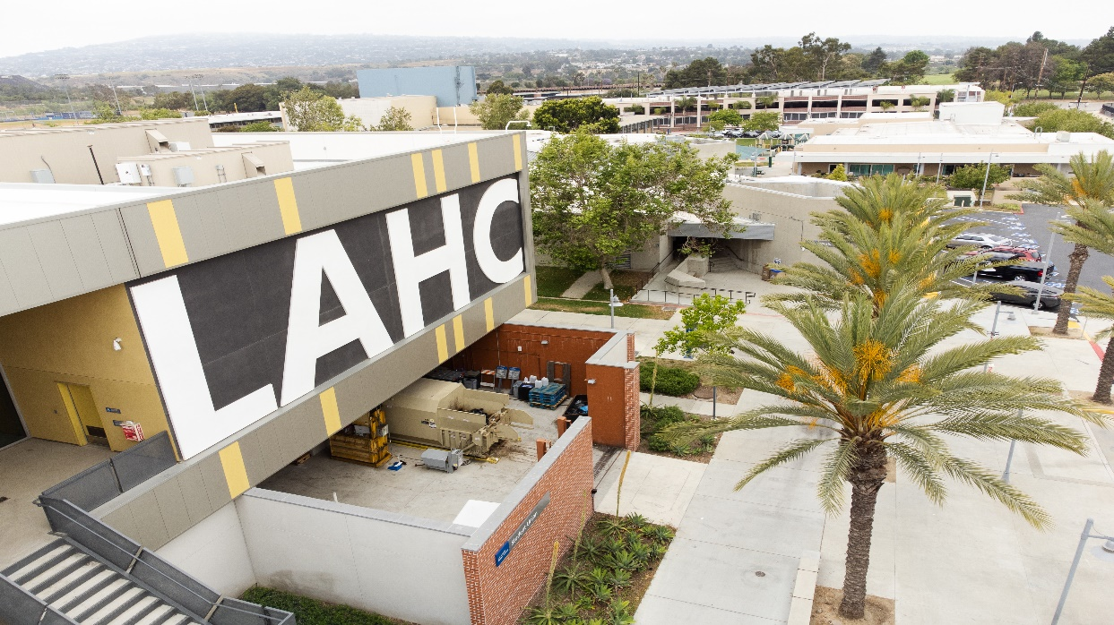

### Fall 2022 Facts at A Glance

|  |  |
| --- | --- |
| Facts at A Glance | Fall 2022 |
| Location and Phone Number | 1111 Figueroa Place  Wilmington, CA 90744  (310) 233-4000 |
| Website | [www.lahc.edu](http://www.lahc.edu) |
| Student Headcount (credit) | 7,644 |
| Male | 39% |
| Female | 61% |
| Hispanic | 62% |
| Asian | 17% |
| Black | 10% |
| White | 10% |
| Multi-ethnic | 4% |
| Pacific Islander | 1% |
| Fees and Tuition |  |
| Enrollment Fee | $46 per unit |
| Student Representation Fee | $2 |
| Health Fee | $19 |
| Out of State/Non-Resident Tuition Fee | $299 per unit |
| International Student Fee | $345 per unit |
| Academic Programs | Associate and Transfer degrees in 56 programs;  credit certificates in 46 programs; non-credit certificates in 15 programs |
| Academic Divisions | 10 academic divisions that are over 76 disciplines |
| Unrestricted General Fund Budget (2022-23) | $44,064,194 |